Translytic: A Real-Time Multilingual Video Translation and Dubbing System
Soham Deshpande, Lokesh Gakhre
Atharva Lingayat, Sanchit Wakde

Abstract— The rise of multilingual digital media has increased the need for tools that can automatically transcribe, translate, and dub video content. This paper presents Translytic, a desktop-based system that integrates speech recognition, machine translation, text-to-speech synthesis, and synchronized playback into a single interface. Developed in Python, it uses Tkinter for the GUI, OpenCV for video processing, Pygame for audio playback, Whisper for transcription, Google Translate or LLM-based methods for translation, and gTTS with pydub for dubbing. The system supports drag-and-drop input, subtitle export, temporary file management, and dual playback modes. Its design separates preprocessing from playback and uses buffered frame handling to ensure smooth rendering. Experimental observations show that the system performs effectively on consumer hardware for short and medium-length videos, while highlighting areas for improvement such as transcription speed, translation quality, and dubbing naturalness.

Keywords— multilingual processing, machine translation, speech synthesis, real-time playback, subtitle generation, audio extraction, FFmpeg, pydub, Pygame, human-computer interaction

I. INTRODUCTION
Video is widely used in education, entertainment, and communication, but language barriers often limit its accessibility. Content like lectures, tutorials, and interviews may not reach a wider audience unless it is transcribed, translated, or dubbed. Traditional methods require multiple tools for each step—audio extraction, transcription, translation, and synchronization—making the process slow and costly, especially for students and small creators.
Translytic simplifies this by combining the entire workflow into a single desktop application. It takes a video file, extracts audio, transcribes it using Whisper, translates the text, and generates a synchronized dubbed audio track. During playback, users can view captions and switch between original and translated audio. It also supports subtitle export for external use.
The application focuses on ease of use and efficiency. Built with tools like Tkinter, OpenCV, and Pygame, it runs locally without complex setup. Its layered design and background processing ensure smooth and responsive performance.

II. RELATED WORK
Automatic speech recognition and machine translation have advanced rapidly in recent years. Modern transformer-based models have improved translation quality, while self-supervised learning has made speech recognition more accurate, even in noisy and multilingual settings. Whisper is especially useful for this project because it generates timestamped text segments, not just plain transcripts. These timestamps are important for subtitles, as they ensure captions are properly aligned with the video.
A typical video localization system involves three main steps: converting speech to text, translating that text, and generating spoken output. Many existing tools focus on only one of these steps. Some generate subtitles but do not provide translation, while others create translated audio without maintaining proper synchronization. Translytic addresses this gap by combining all stages into a single workflow while preserving the timing of the original speech.
Even with the rise of web-based tools, desktop applications remain practical for handling local media files. They are easier to set up and do not require complex backend systems. Translytic builds on this idea by integrating reliable open-source tools into a simple, efficient, and user-friendly solution.

III. SYSTEM ARCHITECTURE
Translytic operates through a simple four-stage pipeline. First, it extracts audio from the video using MoviePy and FFmpeg. This audio is then passed to Whisper for transcription, which generates text along with precise timestamps. These timestamps are essential for both subtitle display and translation. In the next stage, each segment is translated into the selected language. Finally, the system generates a dubbed audio track by placing synthesized speech onto a timeline that matches the original video duration.
The architecture is divided into two main parts: preprocessing and playback. Preprocessing includes tasks like audio extraction, transcription, translation, and speech generation, which are computationally intensive. Playback, on the other hand, is designed to be smooth and real-time. By separating these phases, the system ensures that the interface remains responsive even while heavy processing is ongoing.
To maintain smooth video playback, a bounded queue is used between the decoding thread and the UI thread. OpenCV reads frames in the background, while the UI displays only the latest frame. If delays occur, the system skips ahead using a direct seek, preventing lag and maintaining synchronization at around 30 frames per second.

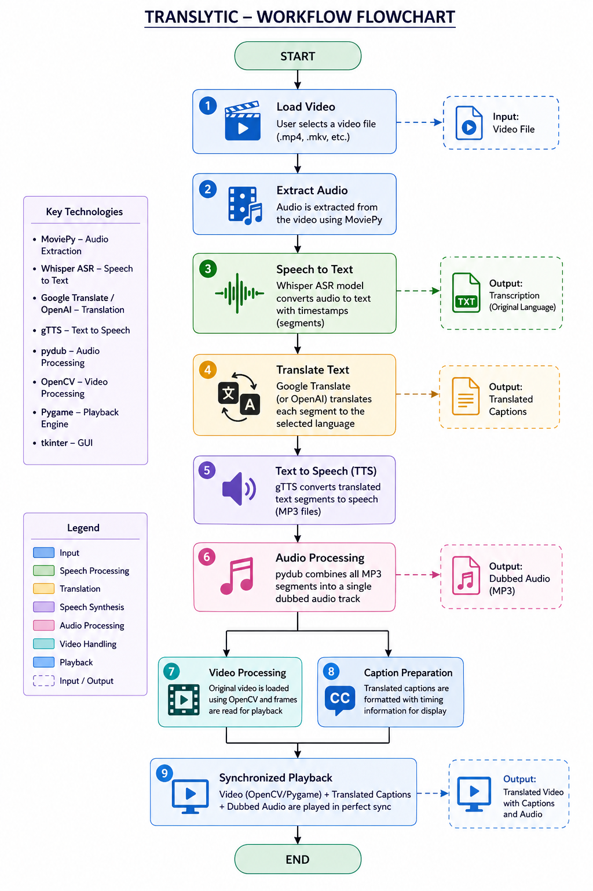
Fig. 1. Translytic Workflow Pipeline

IV. IMPLEMENTATION DETAILS
The implementation begins by simplifying setup for the user. The system automatically installs required packages, checks for FFmpeg, and applies a consistent dark-themed interface, making it easier for first-time users to get started. It brings together several libraries: Tkinter and TkinterDnD2 for the interface, OpenCV for video display, Pygame for audio playback, Whisper for speech recognition, translation tools like Google Translate or OpenAI, and gTTS with pydub for audio generation.
The file-loading process is straightforward. Users can either browse or drag and drop a video into the application. Once selected, the file is loaded, previous data is cleared, and a preview is shown. During processing, audio is extracted into a temporary file, ensuring clean handling without leaving unwanted files behind.
For transcription, the system uses a cached Whisper model to improve speed. Each segment includes timing and confidence details. Translation is done segment by segment, with an option for more natural output using OpenAI. For dubbing, translated speech is placed onto a timeline that matches the video, with adjustments made to maintain sync. Captions update smoothly during playback, and features like controls, shortcuts, and SRT export improve overall usability.

V. USER INTERFACE DESIGN
The interface is designed as a modern dark-themed desktop player. Visual hierarchy is established with gradient headers, accent borders, rounded cards, and a central video canvas. The top control region groups file selection, target language selection, and process execution into clearly separated panels. This layout reduces the cognitive load associated with media-processing applications, where users often need to manage files, settings, status messages, and playback controls at the same time.
The video surface itself uses frame-preserving scaling so that the image fits the available canvas without distortion. When a video is not playing, the player shows a placeholder prompt and a preview thumbnail. When playback is active, the frame decoder updates the canvas while the caption bar displays the currently active segment. This makes the application useful not only as a processor but also as an interactive viewer for checking subtitle timing and reading the translated text in context.
The log panel is an important part of the interface. It reports each major stage of the pipeline and can display warnings about low-confidence transcription segments, cancellation requests, or failures during translation and TTS generation. For a student project, this type of feedback is valuable because it makes the internal pipeline visible to the user and to the evaluator. It also demonstrates good software engineering practice by exposing status rather than hiding it inside the background thread.
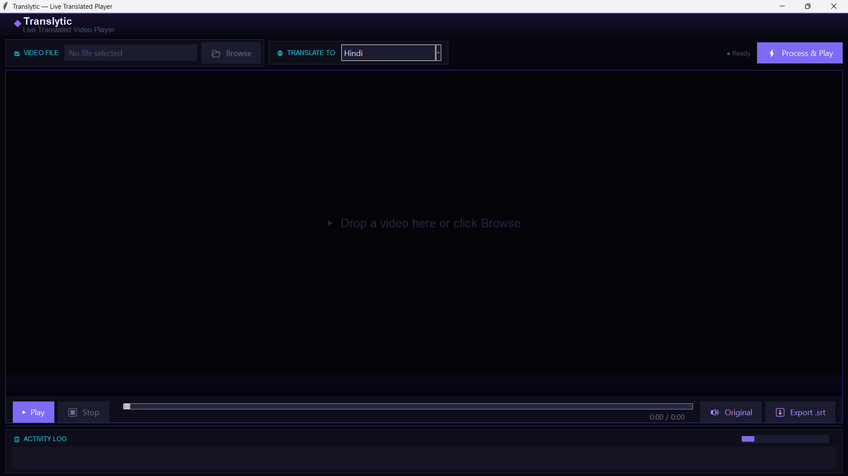
Fig. 2. Translytic User Interface
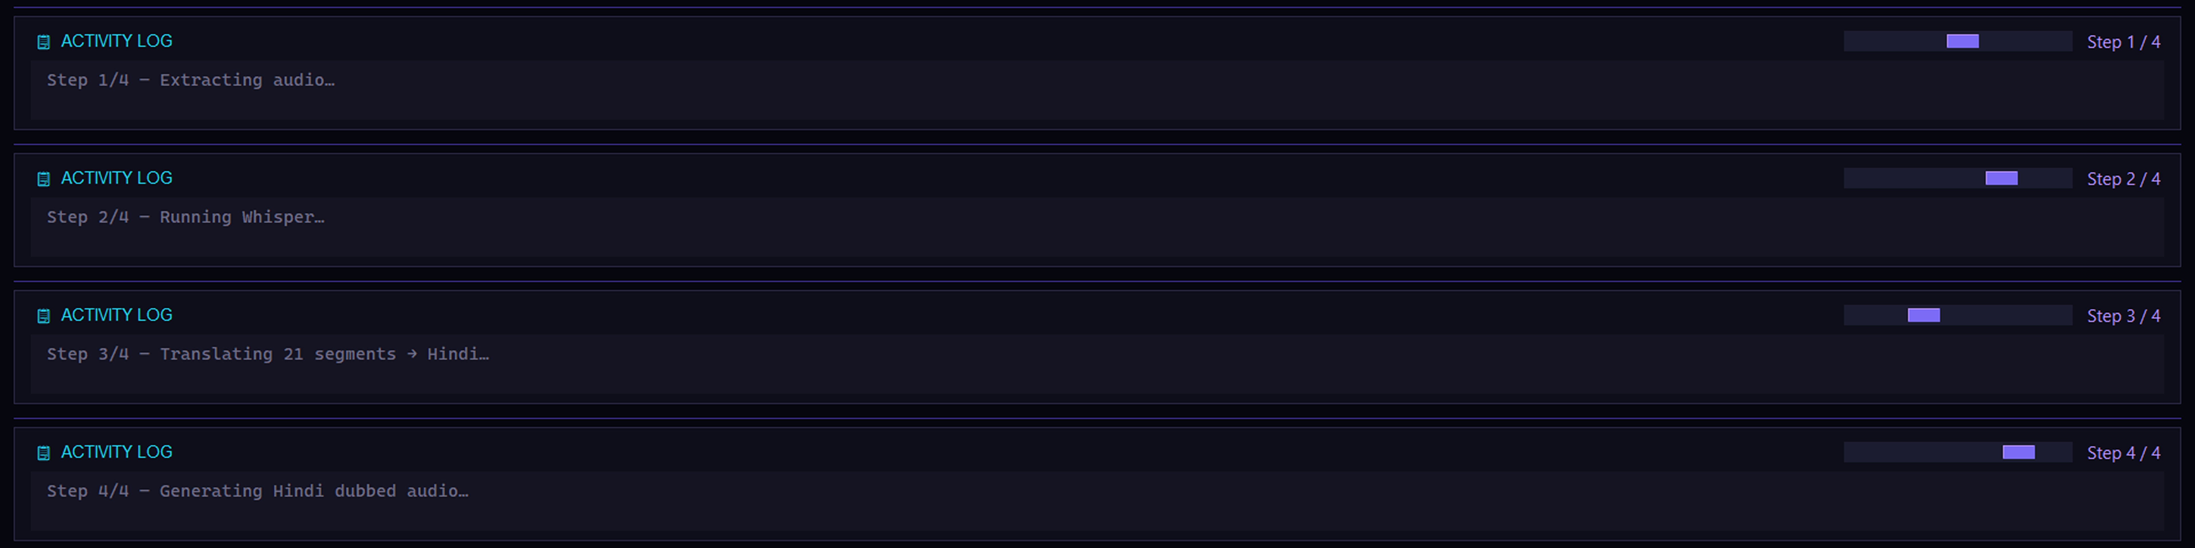
Fig. 3. Activity Log Showing Processing Stages
VI. PERFORMANCE AND EVALUATION
The performance of the Translytic system depends on both hardware capability and network conditions, as it combines local processing with external APIs. In practice, the most time-consuming step is Whisper-based transcription, followed by text-to-speech generation and translation. Audio extraction is relatively fast, and playback remains efficient since it only renders individual frames and updates captions in real time. The use of a fixed frame rate and a bounded queue helps maintain smooth playback even on standard consumer systems.
The system can be evaluated through three key aspects. First, it successfully converts a video into translated captions and dubbed audio, provided the required dependencies and FFmpeg are properly configured. Second, playback remains stable and responsive, with captions updating in sync due to effective UI-thread management. Third, while the caption quality is generally accurate and readable, the dubbed audio may sound slightly unnatural because it relies on basic TTS.
Overall, Translytic works well as a practical demonstration tool for multilingual accessibility. It is suitable for academic use and small-scale applications, though it still requires enhancements such as natural voice synthesis, speaker separation, and lip synchronization for professional use.

VII. DISCUSSION
Several design choices deserve discussion. First, the program uses segment-level translation rather than sentence-level or paragraph-level translation. That decision simplifies timing and keeps the translated text aligned with the source segments, but it can produce slightly awkward phrasing when a sentence is split across two segments. Second, the text-to-speech layer favors simplicity over realism. gTTS is accessible and easy to integrate, but it does not provide rich speaker characteristics. A more advanced neural voice engine would improve perceived quality significantly.
The application also reveals the value of explicit state management. Flags such as playing, paused, busy, and cancelled prevent conflicting operations from being triggered at the same time. Without this discipline, media applications quickly become unstable: a seek action can collide with a play request, a processing request can overlap with file clearing, and cleanup can race with background threads. The code in Translytic shows that careful state transitions are essential for responsive desktop software.
Another useful lesson concerns robustness. The application guards against missing audio tracks, missing FFmpeg, network errors in translation, and temporary file leaks. These checks matter in real-world student projects because a demonstration can fail for environmental reasons that are unrelated to the main idea. By handling those conditions explicitly, the application becomes easier to evaluate and easier to extend.

VIII. LIMITATIONS AND FUTURE WORK
Although Translytic provides a complete pipeline, it has several limitations. First, it relies on CPU-based transcription, which can be slow for longer videos. Techniques such as GPU acceleration, quantized inference, or smaller models could improve performance. Second, the dubbed audio lacks naturalness in languages with varying speech rates, as it does not support advanced prosody or voice adaptation. Third, the system does not include speaker diarization, resulting in all translated speech being generated with a single voice.
Future improvements can address these issues. Replacing gTTS with a neural text-to-speech system would enhance voice quality and expressiveness. Adding speaker diarization would allow multiple voices for different speakers. Support for additional subtitle formats like WebVTT and embedded tracks can improve usability. Batch processing for multiple videos and cross-platform or web-based deployment would further expand accessibility and scalability.

IX. CONCLUSION
Translytic shows that an end-to-end video translation and dubbing pipeline can be built from open-source building blocks and packaged into a usable desktop application. By combining Whisper for transcription, translation services for language conversion, gTTS and pydub for dubbing, OpenCV for rendering, and Tkinter for interface design, the system provides a practical demonstration of multimedia localization. The result is not a replacement for professional studio workflows, but it is a strong academic prototype that clearly demonstrates the structure of modern AI-assisted media processing.
The project is valuable because it brings together core concepts from computer vision, speech processing, natural language processing, and GUI engineering in one coherent implementation. Its architecture also illustrates important software design principles such as separation of concerns, background processing, resource cleanup, and graceful fallback behavior. For future academic development, the most promising direction is to improve voice quality and processing speed while keeping the same easy-to-understand user experience.

TABLE I. CORE TECHNOLOGY STACK USED IN TRANSLYTIC
Component | Library / Tool | Role
GUI | Tkinter, TkinterDnD2 | Interface, controls, drag-and-drop
Video | OpenCV | Frame decoding and canvas rendering
Audio | Pygame | Original and dubbed playback
ASR | OpenAI Whisper | Timestamped speech transcription
Translation | Google Translate / GPT-based fallback | Caption conversion
TTS | gTTS, pydub | Segment-wise dubbed audio synthesis
Media I/O | MoviePy, FFmpeg | Audio extraction and format handling
Image handling | Pillow | Video frame conversion
TABLE II. MAIN PROCESSING STAGES
Stage | Operation | Output
1 | Extract audio | WAV file
2 | Transcribe with Whisper | Timestamped segments
3 | Translate segments | Translated caption list
4 | Generate TTS | Dubbed WAV track
5 | Play and synchronize | Captioned playback
REFERENCES
[1] Google Research, "Real-time Speech-to-Speech Translation," 2025. [Online]. Available: research.google
[2] Meta AI, "SeamlessM4T—Massively Multilingual & Multimodal Machine Translation," 2023.
[3] S. Papi et al., "Direct Models for Simultaneous Translation & Automatic Subtitling," in Proc. IWSLT, ACL Anthology, 2023.
[4] J. Shi, S. Bansal, M. Akbacak, et al., "SBAAM! Eliminating Transcript Dependency in Automatic Subtitling," arXiv / ACL, 2023.
[5] Zhang et al., "Leveraging Broadcast Subtitle Transcripts for Automatic Speech Recognition and Subtitling," arXiv, 2025.
[6] X. Gu, "Text with Knowledge Graph Augmented Transformer for Video Captioning," in Proc. CVPR, 2023.
[7] Y. Shen, "Accurate and Fast Compressed Video Captioning," in Proc. ICCV / arXiv, 2023.
[8] S. Ghimire and P. Pakray, "TRAVID: An End-to-End Video Translation Framework," in Proc. ACL, 2025.
[9] D. Bhatt, "Understanding Video Narratives Through Dense Captioning with Linguistic Modules, Contextual Semantics, and Caption Selection," in Proc. IEEE Conf., 2025.
[10] F. Zhang, "A Comparative Analysis of Human Translation and AI Translation in Humorous Subtitles: A Case Study of Her Story," 2025. (Note: References C. C. Tang, "Research on strategies of humor translation in literary works," 2025).
[11] K. Sindhu, M. Fouzal, A. Vanitha, B. M. Sushma, and C. Varsha, "AI-Powered Real-Time Video Caption Recommendation System," Int. J. Creative Res. Thoughts (IJCRT), vol. 13, no. 4, 2025.
[12] Y. Fu, Y. Yang, and O. Ye, "Video Captioning Method Based on Semantic Topic Association," Xi’an University of Science and Technology, China, 2025. doi: 10.3390/electronics14050905.
[13] V. Vijayabhaskarareddy et al., "AI Enhanced Video Language Translation," 2025.
[14] H. Wei, Z. Tan, Y. Hu, C. W. Chen, and Z. Chen, "LongCaptioning: Unlocking the Power of Long Video Captioning," 2025.
[15] A. R. Oskooei, E. Caglar, I. Sahin, A. Kayabay, and M. S. Aktas, "Generative AI for Video Translation: A Scalable Architecture...," 2025.
[16] R. Kannojia, A. K. Singh, I. Sharma, and S. Gupta, "Gen AI Multilingual Audio Dubbing and Synthesis," 2025.
Explicit external references cited within Lokesh's file:
[17] P. Zhang et al., "Long context transfer from language to vision," arXiv preprint arXiv:2406.16852, 2024.
[18] J. Smith, "Advancements in real-time speech translation," IEEE Trans. AI, vol. 45, no. 3, pp. 123-135, 2023.

